Reference websites https://www.thegoodcharcoal.com
https://www.indiancharcoal.in/
https://www.agrichar.in/

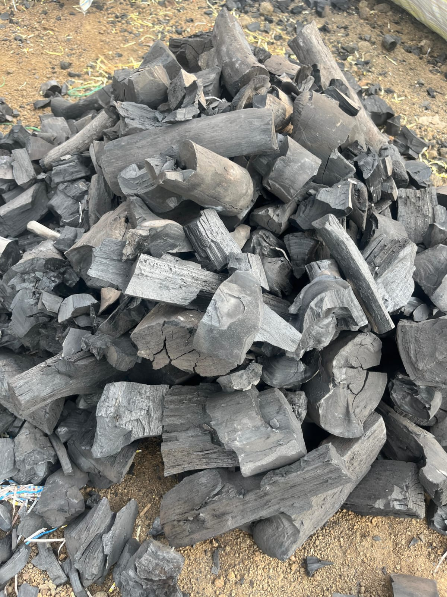
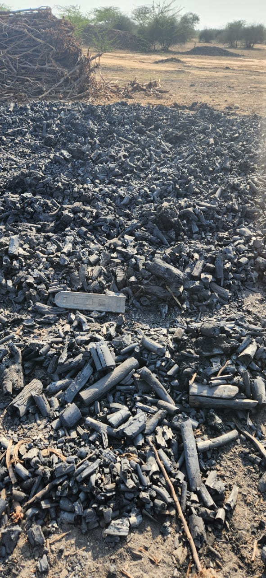
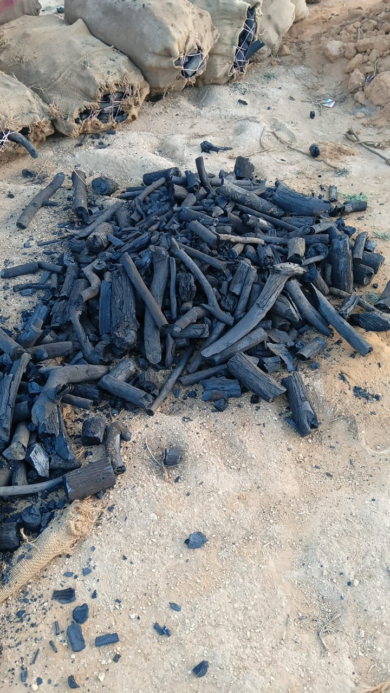

Hardwood Charcoal
1. Hardwood Charcoal kya hai aur kaise banta hai?
Ye asli lakdi se banta hai. Isme koi milaawat nahi hoti.
- Process: Lakdi ke bade tukdon ko ek band bhatti (kiln) mein daal kar bahut tez garam kiya jata hai.
- Magic: Isme oxygen nahi di jati, taaki lakdi jal kar raakh na bane. Isse lakdi ka paani aur gas nikal jati hai aur peeche bachta hai ekdum solid "Carbon" jise hum hardwood charcoal kehte hain

Hardwood Charcoal (industrial use)

Big plant (steel / ferro alloy / export grade)
- Size: 50 mm – 150 mm (lumps)
- Preferred: 80–120 mm
- Low fines: <5–10% max
- Moisture: <8–10%
Use:
- Ferro silicon
- Silicon metal
- High temperature furnaces

Small plant (local / foundry / domestic use)
- Size: 10 mm – 100 mm
- Mixed grading allowed
- More fines tolerated (10–20%)
Use:
- small furnaces
- casting units
- briquette mixing

India me Hardwood Charcoal kahan banta hai
Rajsthan ,Mumbai ,Gujrat maharastra ,chatisgarh, Madhya Pradesh ,odisa ,Karnataka,tamil nadu,
Hardwood Charcoal me kaunsi lakdi use hoti hai
Khejri , babool, Neem wood, Sal wood, Teak wood, Eucalyptus wood, Prosopis juliflora.

2. Iska Use (Kahan kaam aata hai?)
- Metal ka kaam: Lohar aur factory wale loha garam karne ke liye ise use karte hain.
- Paani saaf karna: Bahut se filters mein iska chura (powder) use hota hai gandagi saaf karne ke liye.

hardwood charcoal ferro silicon jalane ke liye 6–20 mm size use hota hai. best size 10–100 mm bhi chalta hai. powder aur bahut bade lumps avoid karte hai.
specification:
- fixed carbon 75–85%
- ash max 3%
- moisture max 5%
- volatile matter 15–25%
ye ladki used hote hai
• Babool wood charcoal (best)
• Acacia hardwood charcoal
- • Dense hardwood lump charcoal

india mai ferro silicon ke plants mostly odisha, Bhutan ,chhattisgarh, jharkhand, west bengal aur meghalaya mai hote hai.
Hardwood charcoal for Ferro Silicon – Specification:
- Size: 6–20 mm (best 10–100 mm)
- Fixed Carbon: 75% – 85%
- Ash Content: max 3%
- Moisture: max 5%
- Volatile Matter: 15% – 25%
- Sulphur: very low (<0.1%)
- Bulk Density: 180 – 250 kg/m³
- Calorific Value: 6500 – 7500 kcal/kg
Ferro silicon plant mai ese used hote hai.
- Hardwood charcoal: 20% – 40%
- Coke / Coal: 60% – 80%

Steel Plant / Furnace me Hardwood Charcoal
1. Blast Furnace / DRI / Sponge Iron

Use hota hai:
- Low ash hardwood charcoal
- High fixed carbon

Size:
- 25 mm – 80 mm (main grade)
- Best: 40–70 mm
- Fines: <5–10% max
Wood source:
- Babool
- Sal
- Teak
- Prosopis (cheap plants)

2. Ferro Alloy / Ferro Silicon Furnace
Use hota hai:
- High carbon, low moisture charcoal

Size:
- 50 mm – 150 mm
- Best: 80–120 mm
- Uniform lump size preferred
Wood source:
- Babool (best)
- Khejri (premium Rajasthan)
- Dense hardwood

Small induction furnace / local units
Use hota hai:
- Broken / mixed charcoal

Size:
- 0 – 25 mm
- Even powder + small lumps allowed

Simple summary (jaise tum likh rahe ho)
- Steel plant (DRI) → 25–80 mm charcoal
- Ferro silicon plant → 50–150 mm (best 80–120 mm)
- Foundry → 10–50 mm
- Small furnace → 0–25 mm mixed

Important industrial point
Steel/ferro silicon plants me demand hoti hai:
- High carbon: 67–85%+
- Low ash: <5–8%
- Low moisture: <8–10%
- Uniform size (bahut important)

hardwood charcoal steel industries mai ferro silicon, ferro manganese aur ferros alloys banane ke liye use hota hai.
kha use hota hai furnace mai:
- submerged arc furnace (SAF) mai sabse zyada use hota hai
- silicon metal production mai
- ferro silicon plant mai
- ferro manganese production mai
- sometimes pig iron aur small reduction processes mai bhi
specification:
- size: 6–20 mm (best 10–100 mm)
- fixed carbon: 75–85%
- ash: max 3% (jitna kam utna better)
- moisture: max 5%
- volatile matter: 15–25%
- bulk density: 180–250 kg/m³

PRODUCT SUPPLY STATEMENT
hardwood charcoal ferro silicon, furnace aur steel industry ke liye required specification ke hisaab se humare paas hamesha available rehta hai, aur hum consistent high quality material supply karte hain, saath hi customer requirement ke according flexible payment terms ke saath timely delivery bhi provide ki jaati hai.

